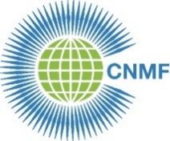
CNMF 25th Biennial Meeting 2022
23-24 September 2022
REGISTRATION FORM

Country:

Type of member (Full, Associate, Affiliate, Individual):
* Full members are those individuals belonging to a national nursing or midwifery association member of CNMF

Title (Miss; Ms; Mr; Dr: Professor):

Last name:

First name:

Email address:

Repeat email address:

Date and time of session: Friday 23 September 22:00 to 01:00 London time
* Please mark one
Saturday 24 September 13:00 to 16:00 London time

Return to: cnf@commonwealthnurses.org BY Friday 16 September
Registration will be acknowledged and a link sent for the nominated meeting.

